9.12: a) Solving Eq. (9.7) for t gives 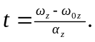
Rewriting Eq. (9.11) as 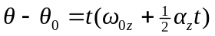 and substituting for t gives
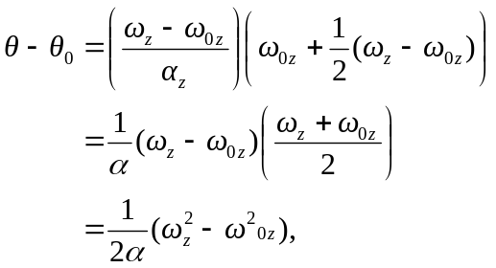
which when rearranged gives Eq. (9.12).

b)
